Driver Proportions Across the US
Kent Roller

Introduction
Infrastructure is a non-negligible cost that every developed nation must account for in order to continue functioning optimally. However, as with the budgets for most expenditures, the budget for infrastructure investments is limited. In order to maximize the effectiveness of these limited budgets, it is necessary to verify that funds are being allocated to the proper locations. But how is it determined which location is the proper one? The method suggested here is to begin the process by looking at the percentage of a states population utilizing the roadways. States with higher a higher proportion of drivers on the roadway would more likely require more funding than states that have lower proportions of drivers. States that have a lower proportion of drivers on the road but higher proportions of Amtrak riders for instance, would more likely benefit from additional investment in the train lines and other public transport in the region. To this extent, the aim here is not to provide a concrete formulaic answer to funding in various regions, instead, the intent is to provide some general insight into how driver proportions within states vary based on a variety of factors. Those factors, for the extent of this purpose, have been chosen as the fuel tax rate in the state, the unemployment level in the state, the Amtrak riders in the state, the road condition, and the total population. Using these, a model will be generated to examine these factors and their role in driver proportions. Doing so, the end goal is to provide a jumping off point for deeper analysis once the key areas of interest have been identified.

Data and Analysis
The primary data set selected is the licensed drivers data set which contains the number of drivers in each states segmented by age group. This will be the data set on which all other datasets are added when the merge occurs. A brief overview of the licensed drivers dataset:
- Year: The year the observation took place, observations range from 1994-2018

- Gender: The gender of the driver with two values, male and female

- Cohort: The age group of the drivers

- State: The state in which the observation took place

- Drivers: The number of drivers in each cohort

The dataset was mostly clean and required little pre-processing before it was ready to use. The column names imported cleanly, and there was only one missing value which was resolved using the isna mean replacement method. After loading and cleaning the first data set, the other datasets needed to be cleaned and readied for merging as well. The Amtrak Riders dataset was the next data set to be cleaned. The Amtrak Riders data contained the years 2005-2022. This is a mismatch with the years contained in the original dataset, as such, the original data set must be trimmed to 2005. So, after trimming both the original data and the Amtrak riders data to both contain the ranges 2005-2018, a NaN count on the Amtrak riders was performed. Once again there were a few NaNs that need to be resolved, and once again, the mean method is used to fill in the missing values without removing and of the rows or columns.
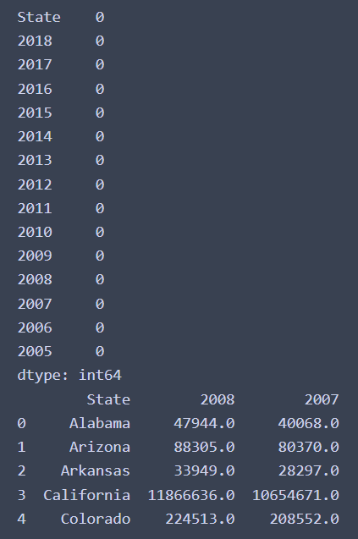
Figure 1.1
Figure 1.1 shows the Amtrak data after preprocessing has taken place. The NaN count is shown at the top of the image, where it can be seen each value shows 0 beside of it, indicating there are no NaN values in the dataset. The lower portion of the image in Figure 1.1 shows the columns after they have been replaced with the years that the observation took place. After preprocessing of the Amtrak riders data set, the fuel rate data set. The fuel rate data set contains the fuel tax rate by state as well as the effective data for the tax rate in the state, fuel type, and notes. Due to the structure of the dataset, and since only one observation per state is made, the values here will be treated as constants. Additionally, since many of the columns here contain data that is not required, as well as missing values, the columns will be removed from the data.
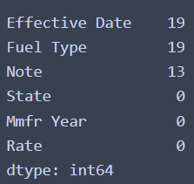
Figure. 1.12
Figure 1.12 shows the fuel rate dataset before preprocessing occurs. The image shows the NaN count for each column in the dataset. As can be seen in the image, the NaN count is somewhat high compared to the number of observations contained in the data. However, this information is not required for the analysis we intend to perform. \
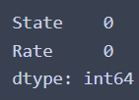
Figure 1.13
The fuel data set after pre-processing can be seen in figure 1.13. The figure shows the unnecessary columns have been removed from the dataset and a NaN count has been reperformed. After the fuel data has been pre-processed the next data set is selected, this time loading the Road Condition dataset. The road condition dataset contains a lot of information about the road condition on all roads throughout the US. These measures are broken down by overall state measure of acceptable roads by miles and percentage. The dataset goes into more granular data, however this granular data that delves into the type of roads and their condition is not needed for this analysis.
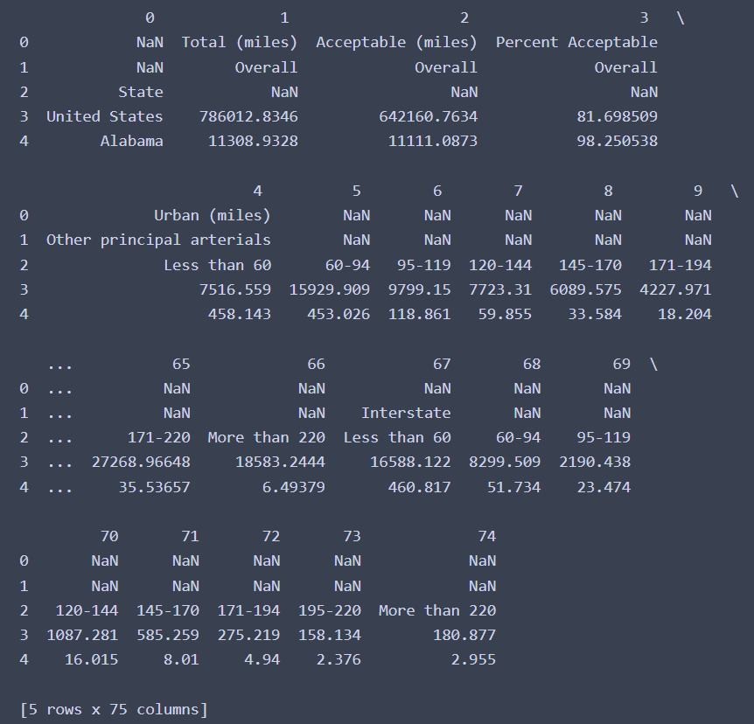
Figure 1.14
The dataset for the road condition is shown in figure 1.14. As can be seen in the figure, the dataset as imported is a bit of mess, where there are missing values at the top of every column. Additionally, there are no column names. The first step was to trim the data to remove the blank space from the top of the dataset. After the blank space was removed, the columns were renamed appropriately. Lastly, since many of the additional columns are not needed, they are removed, leaving the State, Total Miles Overall, Acceptable Miles Overall, and Percent Acceptable Overall. After cleaning the dataset is in a much more usable state.
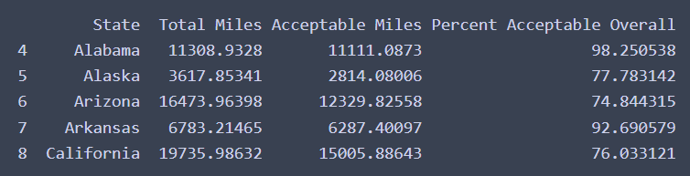
Figure 1.15
Figure 1.15 displays the road condition data set trimmed down with the column names relabeled.
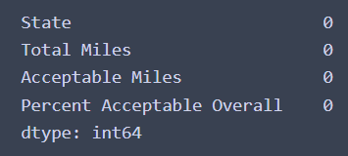
Figure 1.16
Figure 1.16 displays the NaN count of the road condition dataset. As can be seen in the figure, the NaN values have been successfully removed from the data, and the columns are trimmed down to the appropriate number needed for analysis. After this step has been completed, the road condition dataset is ready for use. As such, the next dataset will be pre-processed. The next dataset that needs to be cleaned is the unemployment dataset. Much like the road condition dataset, the unemployment dataset requires extensive cleaning to make usable.
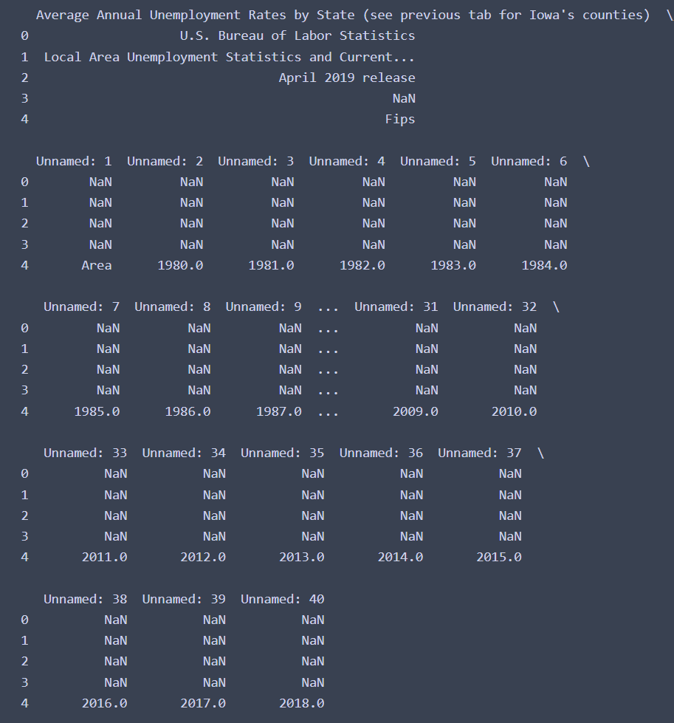
Figure 1.15
Figure 1.15 displays the unemployment dataset as it is imported. Like the previous dataset the unemployment dataset will require extensive work before it can be used in analysis. Once again, the columns that are being retained are relabeled with appropriate names. Likewise, the blank space at the beginning and at the end of the dataset is removed. Lastly, the years of information contained within the dataset are trimmed to better capture the same data as the primary dataset. In this instance we trim the data down to only contain the years of interest, that being, 2005-2018 as dictated by the Amtrak riders data from earlier. Once the data has been pre-processed its appearance is much more presentable.
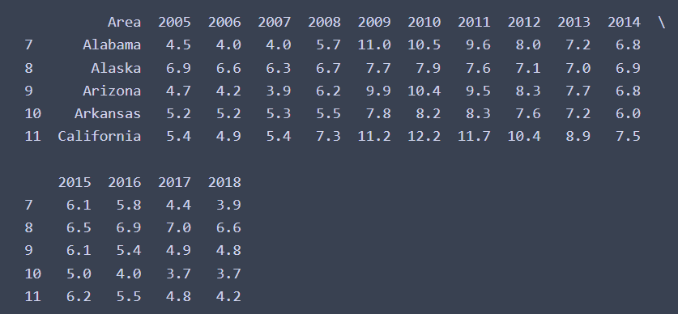
Figure 1.16
The pre-processed unemployment data can be seen in figure 1.16. The last step of the pre-processing that had to be completed before being able to merge the datasets was one last column name change. All of the other datasets used so far labeled the areas as “State”, where as this data set has chosen to use the word “Area”. In order to simplify the merging process the column “Area” was renamed to “State”. After this step was completed, the data set was finished in terms of pre-processing. The last data set to be loaded was the population data set, which fortunately was clean and did not require any pre-processing steps other than trimming the years to match the other datasets being used.

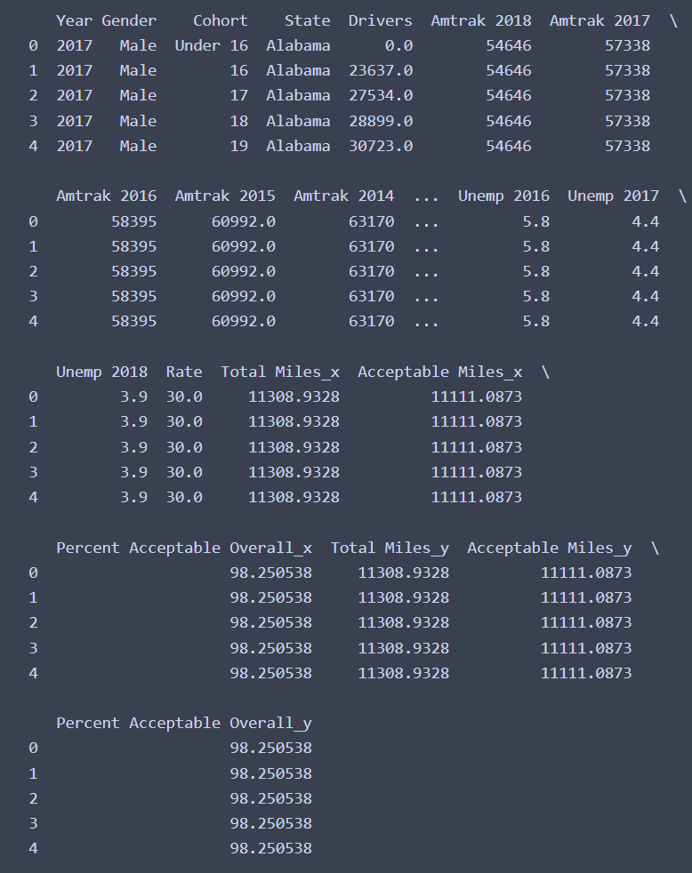
Figure 1.17
Figure 1.17 displays the initial attempt at merging the datasets. When initially merging the data, used the pandas method merge, passing the arguments on=”State” and performing an inner join. As can be seen in the figure however, this resulted in a joining that rendered the dataset unusable. The Amtrak values for all years are mixed in with the driver values for all years, so trying to call individual or unique values for a given year or state will be complicated by this arrangement. In order to circumvent this issue, melt was used on the Amtrak Riders data and the Unemployment data in order to make it conform to the structure set forth by the original dataset.
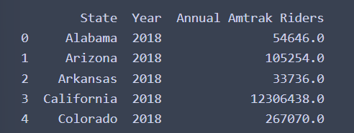
Figure 1.18
Figure 1.18 shows the Amtrak Riders dataset after the melt has been performed. Now the data is rearranged in a way that makes sense for the join that is being performed. The second attempt at merging with the melted datasets resulted in better output.
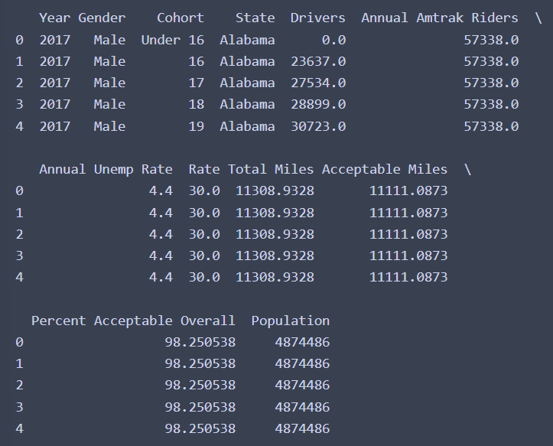
Figure 1.19
The merged dataset can be seen in figure 1.19. Here, the melt has been performed and the datasets that were joining with errors are joining correctly now. However, there is one additional step that must be completed before the analysis stage can begin. That is, raw counts cannot be used as a comparison between states. If this was done, then the states with the highest populations would be in the top 10 count and the states with the lowest populations would be in the least 10 counts. Instead, a comparison needs to be made among the proportion of the population that is on the road each year in each state. To do this, the cohorts for each year and state are summed to get a total for that year and state. The total of drivers is then divided by the total population of the state for that year. This is performed for all states and years within the drivers data. Additionally, the Amtrak riders is converted to proportions for the same reason.
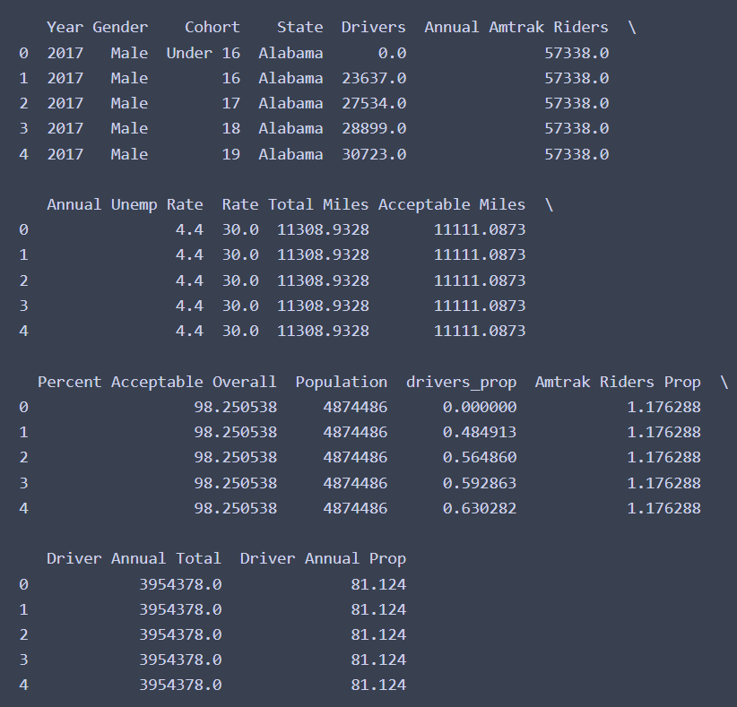
Figure 1.20
Figure 1.20 shows the further modified dataset, where the proportions for both drivers and Amtrak riders have been added. This will allow for a more accurate comparison between states. The effect of this can be seen in the counts for the top 10 states for driver proportions, where heavily populated states such as California are not present.
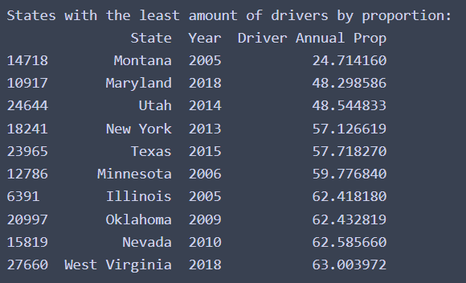
Figure 1.21
Figure 1.21 shows the counts for the least 10 states by driver proportion. Montana leads the pack at only 24% of the population driving during the 2005 year, though this count may be a reflection of a possible error in the conversion of the population from an abbreviation to the full state name. Other surprises include the New York population being among the least 10 counts, though given that the greatest concentration of the population is located within the city and the city has extensive public transportation infrastructure this is not surprising. What is slightly more surprising is that Texas is also among this count, as the states response to increased traffic in the past has been to simply increase the lanes of the road. It would appear that at some point after developing swathes of 12 and 14 lane super highway projects they have decided that indefinite road growth may not be the optimal approach to the problem. As a result, through the use of increased investment in public transportation Texas has been able to keep the proportion of its drivers low compared to other states.
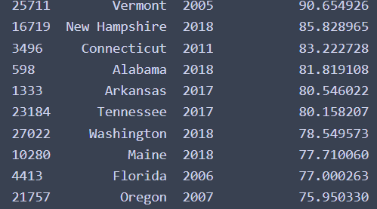
Figure 1.22
The top 10 driver proportions by state are shown in figure 1.22. Some interesting observations are the high count for Vermont, New Hampshire and Connecticut. Perhaps due to the fact that their populations are low compared to some other states the proportion of their population driving is higher than with other states. Other states with high driver proportions are most likely a reflection of a lack of investment in public infrastructure in those states, or the cities are less numerous and less populous than some of the other states in the list. The same insight can be gleaned about the Amtrak riders since it was also converted to a proportion instead of an count.
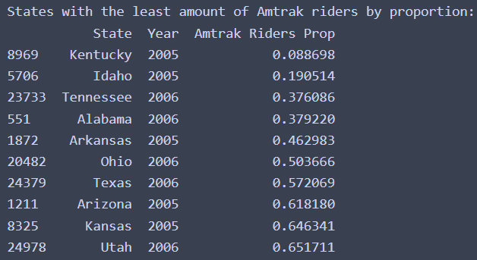
Figure 1.23
The 10 states with the lowest Amtrak rider proportions are shown in figure 1.23. These states most likely have the lowest proportions due to a lack of amtrack rail running through the state. Unfortunately the total mileage of rail available in each state is not known at this time so this remains speculation.
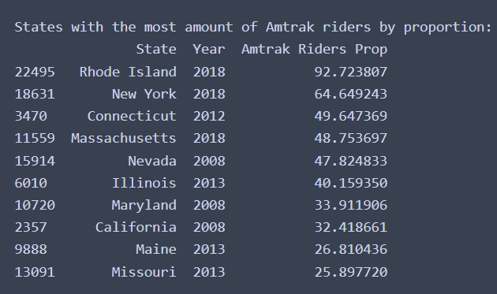
Figure 1.24
The top 10 states with the highest proportion of Amtrak riders is shown in figure 1.24. Once again, with the lowest counts, these make some intuitive level of sense as this is where Amtrak primarily operates and has the highest density of railways it operates on.

Modeling
From here, the next stage is progressed to. This requires proving that there is a statistically significant difference between the proportions across states. However this poses a couple of different problems. The first being the distribution of the dataset is unknown for any variable, let alone the variable of interest. Additionally, the variance of the dataset are known either. This poses problems with trying to use methods such as t-test or welch’s t-test as both have preconditions for use pertaining to either the distribution or the variance of the data. As such a method will need to be selected that does not rely on this information. To this effect the permutation method is selected, as it is a non-parametric method that does not require a particular distribution or variance to be able to work with the data. This is due to the way the permutation method works, where the samples are taken randomly and tested over several 1000 or more iterations. On the initial performance of the permutation test the number of permutations selected was 10000. Using this method the p-value found was equal to 0. To make sure this was not an error the number of permutations was increased to change the accuracy of the p-value, after re-running the permutation with the number set to 100,000 permutations a p-value of 1.0x10-5 was found. This shows that the null hypothesis of the permutation can be rejected, which means that the distributions from which the proportions come from differ from one another. This means that these measures are significantly different from one another. But what is causing this difference? The first method used to try and answer this question is linear regression. The proportion of drivers in each state will function as the y variable or the response and the x variable or the predictors will be the Amtrak riders proportion, the fuel rate, the road condition, and the unemployment rate. The total population information will not be used as this was only required for the creation of the proportions.
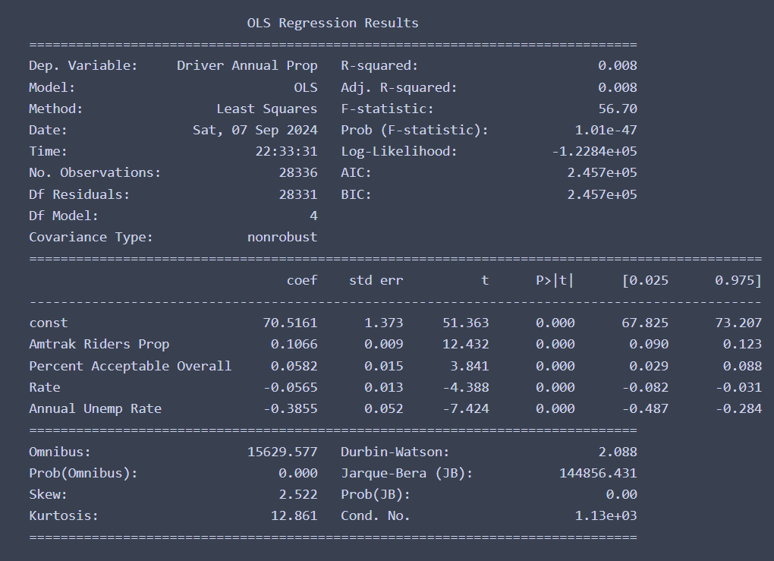
Figure 1.25
The output for the regression is shown in figure 1.25. As can be seen, the model performance is nothing short of abysmal. The R-squared value is much less than 1%, meaning that less than 1% in the amount of variation in the response can be explained by the predictors. There are some interesting relationships shown in the coefficients, where Amtrak riders and acceptable roads had a positive coefficient while unemployment and fuel tax rate had a negative coefficient. However, since the model is not significant, none of the coefficient measures are significant either and as such should be disregarded. Since the performance of linear regression is so bad, another method is required. Multi-Collinearity between observations may be a contributing factor to the poor performance of the model. In an attempt to circumvent potential issues stemming from this, ridge regression is attempted next. Running the ridge regression resulted in a very slight increase in R^2 score, from 0.008 to 0.009, however, this improvement still yields less than a 1% explanation rate.
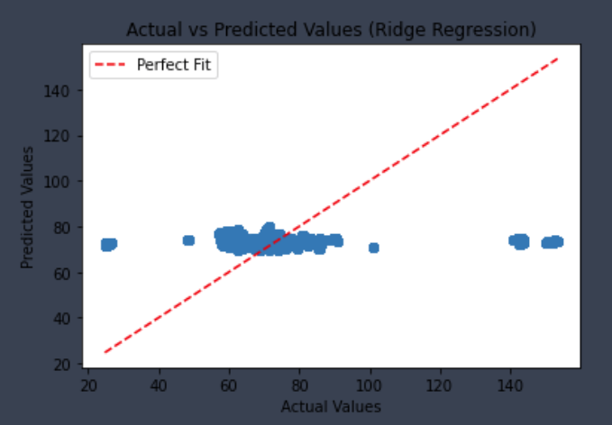
Figure 1.26
Figure 1.26 displays the scatterplot of predicted versus actual values using the ridge regression. As can be observed in the scatterplot, the ridge regression captured non of the behavior exhibited by the data. This is reflective of the poor R^2 value achieved. Once again, another model will need to be tried in the hopes of gaining a better performance. For the next model, a Random Forest Regressor is used. The random forest should be able to handle the shape of the data.
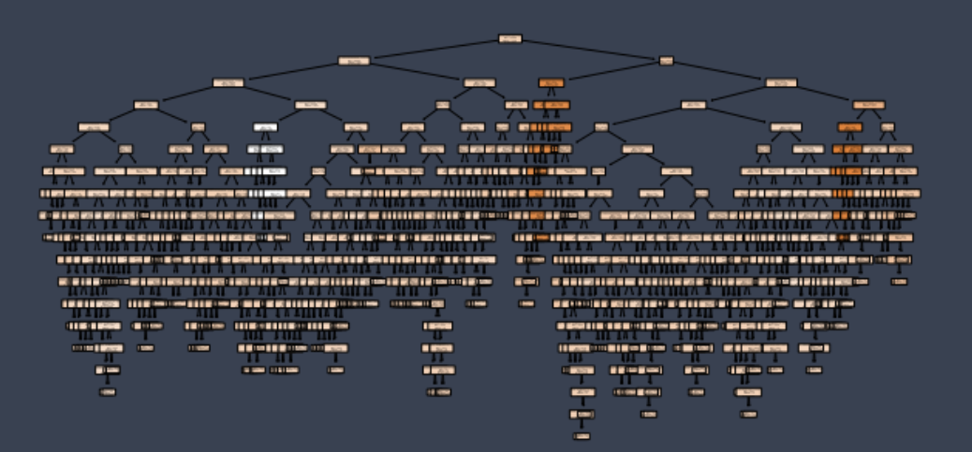
Figure 1.27
One of the trees generated using random forest can be seen in figure 1.27. This method unfortunately exhibited the complete opposite problem of the previous models resulting in a p-value=1. This is unfortunate as it suggest the model is grossly overfitted to the data and as such would be unusable for analysis.
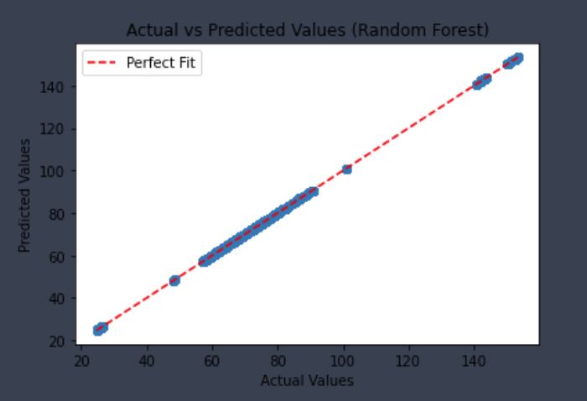
Figure 1.28
The scatterplot in figure 1.28 shows the predicted versus the actual values using the random forest regressor method. As was reflected in the r^2 value, the scatterplot shows the gross overfitment of the line where the datapoints map to the line perfectly. This renders the random forest regressor useless for this dataset.
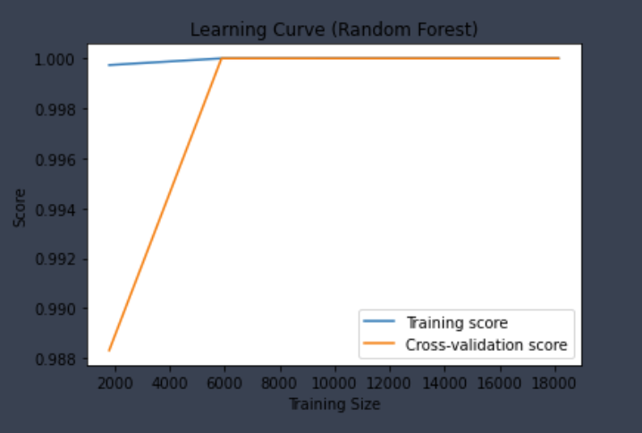
Figure 1.29
The learning curve plot shown in figure 1.29 shows the training score performance against the cross validation performance of the model. As was the case in the previous figure, this plot shows the overfitment of the model through a different lens. The training score immediately adopting the value of 1 is not realistic, nor is the rapid learning of the cross validation score and constant overlay of the training data. As stated, this only further showcases the overfitment of this model. One last model will be used, which utilized Support Vector Regressors. This is in the hope that this method can circumvent the issues found by using the other models. Unfortunately, the improvement, while large in comparison to the previous models, only yielded a r^2 value of 0.07. This is again, a substantial improvement over the previous models, but still lackluster as a model.
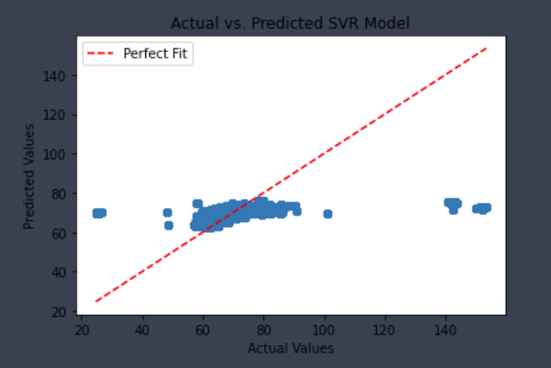
Figure 1.30
The scatterplot in figure 1.30 shows the poor performance accomplished by the SVR model by comparing the predicted values to the actual values.

Conclusion
After loading in the datasets, the datasets were cleaned and made ready for use. Once ready for use, the datasets were combined into one dataset for analysis. Permutations were then used to show that there existed a difference between states, however, none of the models were able to showcase the reason for this. Why this has happened can be attributed to one of several reasons. The first being that the models selected were inappropriate for the data. If a relationship could not be established via regression, then a non-linear method should be considered. Second, a more robust dataset may be required, as this particular response variable may have many more factors that contribute to its variance. Third, the data may require further pre-processing to meet the requirements of the models. Every pre-caution was taken to make sure that the models selected were appropriate, but failure to consider proper data structure may have occurred. As such, this should not be viewed as a definitive word on driver proportions, but instead as an overview of data cleaning and model selection.

References
[1] https://www.kaggle.com/datasets/ibrahimonmars/licensed-drivers-by-state-gender-and-age-group
[2] https://www.bts.gov/browse-statistical-products-and-data/state-transportation-statistics/amtrak-ridership
[3] https://www.bts.gov/road-condition
[4] https://www.icip.iastate.edu/tables/employment/unemployment-states
[5] https://github.com/JoshData/historical-state-population-csv/blob/primary/historical_state_population_by_year.csv

